Hospital ERP System

Team - 5:
- Zeyad Hemeda
- Ahmed Gamal
- Taha Ashoush
- Youssef louis

Project Proposal
The Small Hospital Management System is a web-based application developed using ASP.NET MVC and Microsoft SQL Server. It automates patient registration, appointments, billing, inventory, and employee management, following the MVC structure.

Objectives:
  - Automate hospital operations and improve efficiency.
  - Provide secure access through role-based authentication.
  - Manage billing, invoices, medications, and reports.
  - Ensure reliable and easy deployment for small hospitals.

Project Plan (10 Weeks)
Team: 2 Backend Developers + 2 Frontend Developers
Tools: ASP.NET MVC, SQL Server, Visual Studio 2022, Entity Framework, Bootstrap, GitHub, IIS.

Gantt Chart (10 Weeks)

Week | Task | Start Date | End Date | Deliverables
1 | Requirements & DB Design | 2025-10-06 | 2025-10-12 | ERD + Project Setup
2 | Core Models & CRUD | 2025-10-13 | 2025-10-19 | Patient & Employee CRUD
3 | Authentication & Roles | 2025-10-20 | 2025-10-26 | Login & Role System
4 | Appointments Module | 2025-10-27 | 2025-11-02 | Appointments Scheduling
5 | Medical Records | 2025-11-03 | 2025-11-09 | Medical Records UI
6 | Billing & Invoices | 2025-11-10 | 2025-11-16 | Billing Module
7 | Billing & Invoices (cont.) | 2025-11-17 | 2025-11-23 | Invoices Reports
8 | Inventory & Medications | 2025-11-24 | 2025-11-30 | Inventory & Expiry Alerts
9 | Testing & QA | 2025-12-01 | 2025-12-07 | QA & Bug Fixes
10 | Deployment & Documentation | 2025-12-08 | 2025-12-14 | Deployed System + Docs

- Task Assignment & Roles
Backend Dev 1 – Database & Core Logic (SQL Server schema, Entity Framework) Backend Dev 2 – Billing, Invoices, Medications
Frontend Dev 1 – Razor Views for Patients, Appointments Frontend Dev 2 – Billing & Inventory UI, Validation, Testing

Risk Assessment & Mitigation
  - DB schema changes mid-project → Lock schema after Week 2
  - Controller/View mismatch → Use shared ViewModels
  - Authentication bugs → Test early with ASP.NET Identity
  - Deployment issues → Test on IIS early

KPIs (Key Performance Indicators)
  - Response time ≤ 2 seconds
  - Uptime ≥ 99%
  - Billing accuracy ≥ 98%
  - Patient registration time ≤ 2 minutes
  - Test coverage ≥ 80%
  - On-time delivery ≥ 90%

MVC Architecture Breakdown
PatientsController → Manage patients (CRUD) EmployeesController → Manage staff AppointmentsController → Scheduling MedicalRecordsController → Records BillingController → Invoices & Payments MedicationsController → Inventory & expiry AccountController → Authentication HomeController → Dashboard & reports

Deliverables
  - ASP.NET MVC Solution (C#)
  - SQL Server Database + Scripts
  - Documentation (Word/PDF)
  - Testing & Deployment Report
  - Presentation Slides

Hospital ERP System
Stakeholder Analysis, User Stories, and Use Cases

Stakeholder Analysis
Key Stakeholders and Their Needs:
- Patients: Need easy registration, appointment scheduling, billing transparency, and access to medical history.
- Doctors: Require access to patient records, appointment management, diagnosis tools, and treatment tracking.
- Nurses: Need to access patient care plans, medication schedules, and update treatment progress.
- Receptionists: Handle patient registration, appointment scheduling, and initial billing entries.
- Pharmacists: Manage medication inventory, issue prescriptions, and handle medication billing.
- Administrators: Oversee departments, employees, reports, and ensure compliance and efficiency.
- Accountants: Need tools for invoice management, payment tracking, and financial reporting.

User Stories & Use Cases
- Patient Books Appointment: As a patient, I want to book an appointment with a doctor online so that I can receive timely medical consultation.
- Doctor Reviews Patient Record: As a doctor, I want to view and update patient medical records to provide accurate diagnosis and treatment.
- Receptionist Registers New Patient: As a receptionist, I want to register new patients quickly to streamline the hospital admission process.
- Pharmacist Issues Medication: As a pharmacist, I want to track and issue medications to patients based on prescriptions.
- Administrator Generates Reports: As an administrator, I want to generate reports about hospital operations for better decision-making.
- Accountant Processes Payment: As an accountant, I want to review invoices and update payment statuses to maintain accurate financial records.

System Modules Summary
The Hospital ERP includes modules for:
- Patient Management (Patients, Medical Records, Diagnoses, Treatments)
- Appointments Scheduling
- Billing and Invoicing
- Human Resources (Employees, Departments, Roles)
- Inventory and Medication Management
- Reporting and Analytics

Hospital ERP System

Problem Statement & Objectives
Problem Statement
Small and medium-sized hospitals often face major inefficiencies in handling administrative, medical, and financial operations. Without a centralized system, hospitals rely on paper-based or disconnected digital tools, leading to:
  - Redundant patient data entries
  - Appointment mismanagement and scheduling conflicts
  - Errors in billing and payment tracking
  - Lack of visibility into employee roles and working hours
  - Poor medication inventory control
These issues negatively affect operational efficiency, data accuracy, and the quality of patient care.
Objectives
The Hospital ERP System aims to deliver an integrated and user-friendly platform for managing all hospital operations in one place.

Project Objectives:
- Centralize hospital operations — unify patient, billing, HR, and inventory data.
- Enhance service efficiency — automate appointment booking, invoicing, and reporting.
- Ensure data integrity — use MSSQL with enforced foreign key constraints.
- Support role-based access control — secure sensitive medical and financial data.
- Provide actionable insights — generate real-time reports for hospital administration.
- Deliver a scalable architecture — built using .NET Core MVC and MSSQL Server
for reliability and future expansion.

Use Case Diagram & Descriptions
System Actors

Actor Role / Responsibility
Admin Manages users, departments, and system-wide settings
Doctor Accesses patient medical records, adds diagnoses, and manages treatments
Receptionist Registers patients, schedules appointments, and issues invoices
Pharmacist Manages medication inventory and dispensing
Accountant Handles invoices, payments, and generates financial reports
Patient (Optional) Views appointment details or invoices via patient portal

Use Case Diagram
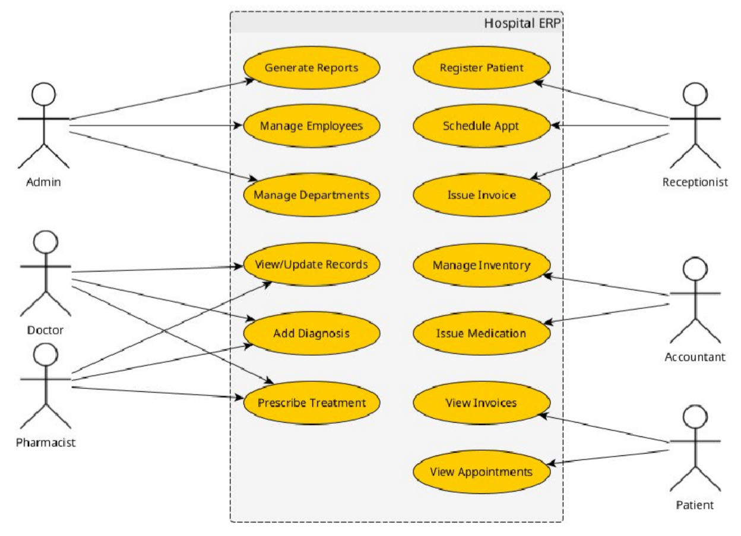
Use Case Descriptions

Use Case Primary Actor Description
Register Patient Receptionist Create a new patient record with personal and
contact details.
Schedule Appointment Receptionist Assign a doctor and time for patient
consultation.
Record Diagnosis Doctor Add or update patient medical diagnosis and
link treatment.

Manage Medication Inventory
Pharmacist Track stock, update quantities, and monitor
expiry.

Generate Invoice Receptionist / Accountant
Create invoices for medical services and medication.

Manage Employees Admin Add, edit, or remove hospital employees and
define roles.
Generate Reports Admin / Accountant Generate daily, monthly, or annual reports for
management.

Functional & Non-Functional Requirements
Functional Requirements

Module Requirement
Patient Management Add, edit, and retrieve patient records with unique ID and linked medical history.

Appointment Management
Schedule, update, cancel, and view appointments between patients and doctors.

Medical Records Store diagnoses and treatments for each patient, linked with doctor and date.
Billing System Generate invoices, calculate totals, track payments, and link services and medications.
Inventory Management Maintain a list of medications, quantities, costs, and expiry dates.
Employee Management Manage hospital staff with roles, departments, and schedules.
Reports Generate summaries (e.g., total patients, revenue, medication usage).
Non-Functional Requirements

Category Description
Performance The system must respond to user actions within 2 seconds under normal load (≤100 concurrent users).
Scalability Designed to support future modules (e.g., lab, radiology) with minimal restructuring.
Security Implement ASP.NET Identity for authentication and role-based authorization for different staff roles.
Data Integrity MSSQL Server enforces referential integrity via foreign key relationships defined in the ERD.
Availability The system should operate with at least 99% uptime during business hours.
Maintainability The MVC pattern separates business logic from UI for easier debugging and updates.
Usability The system should have an intuitive and clean interface using Razor Pages
and Bootstrap.

Backup & Recovery
MSSQL database backups scheduled daily with recovery plans for critical data loss scenarios.

Compatibility Compatible with modern browsers and deployable on Windows Server environments.

Software Architecture
Architecture Overview
The Hospital ERP System is designed using the Model–View–Controller (MVC) architecture pattern within the .NET Core Framework.
It provides a clear separation of concerns, improving maintainability, testability, and scalability.
High-Level Component Architecture
Layer Description Technologies

Presentation Layer (View)

Controller Layer (Business Logic)
Model Layer (Data Access)
User interface for hospital staff to interact with the system — built using Razor Views with Bootstrap for responsive design.
Processes user requests, interacts with models, and returns appropriate views or JSON responses.
Represents entities and manages data access through Entity Framework Core.
Razor Pages, HTML, CSS, Bootstrap

ASP.NET Core
Controllers

EF Core, LINQ

Database Layer Stores all hospital data in a relational format according to the ERD.
Microsoft SQL Server

Authentication & Authorization
Manages user login, roles, and permissions. ASP.NET Core Identity

Reporting & Analytics
Architecture Diagram
Generates reports and analytics dashboards for admins and accountants.
RDLC /
FastReport.NET / Razor Reports

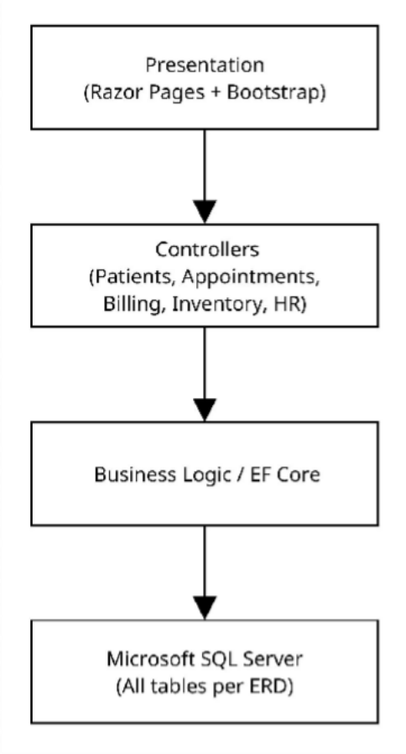
Deployment Details
- Framework: .NET Core MVC 8.0
- Database: Microsoft SQL Server (MSSQL)

- Hosting: IIS or Azure App Service
- ORM: Entity Framework Core (Code-First or Database-First approach)
- Authentication: ASP.NET Core Identity with Role-based Authorization
- Reporting: RDLC / FastReport.NET integrated with Controllers

System Deployment & Integration
Technology Stack
The Hospital ERP System is built using a modern and scalable technology stack:
- Backend:
  - ASP.NET Core 8.0 MVC
  - Entity Framework Core (Code-First / Database-First)
  - ASP.NET Identity for Authentication and Authorization

- Frontend:
  - Razor Pages (MVC Views)
  - HTML5, CSS3, JavaScript
  - Bootstrap (Responsive UI)

- Database:
  - Microsoft SQL Server (MSSQL)
  - Stored Procedures, Views, Foreign Key Constraints

- Reporting & Analytics:
  - RDLC / FastReport.NET / Razor Reports

- Hosting & Deployment:
  - IIS (On-Premises) or Azure App Service (Cloud Hosting)

Deployment Diagram
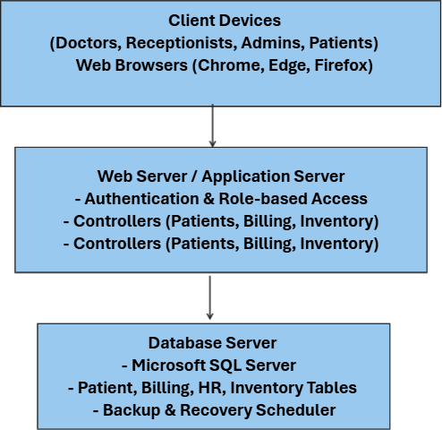

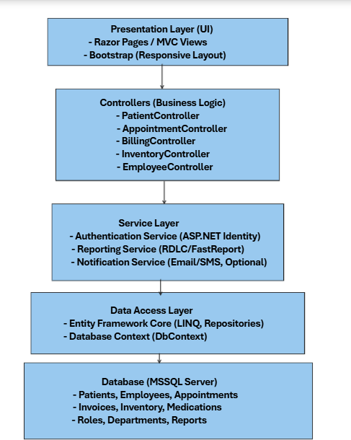
Component Diagram

